# Assignment Structure

The case study for this assignment (see CP4P_Final_Assignment Case Study.docx file) and its deliverables are representative of many ICT projects. The project management artifacts – Proposal, Budget, WBS – are standard practice. You might very well have to write, review, and/or evaluate them in your future IT career. End user Training Modules are delivered in small, guided videos; the assignment requires your group to create an example of one. (These are why the Communicating Across Contexts and Business Report Writing courses are an essential part of your program.)

**Your team is bidding on – *not doing* –** **a potential client's internal IT infrastructure upgrade project as described in the case study. Your boss (instructor) has assigned your group the task of responding to the potential client's** [**Request For Proposal**](https://en.wikipedia.org/wiki/Request_for_proposal) **(RFP).**

You will start by developing an Assignment Plan for your team to create a Project Proposal, Budget, WBS–Work Breakdown Structure, and a Training Module. These artifacts, as they are called in project management, are your response to the client's RFP and will be submitted to the client for their evaluation. The client will decide if your team will be selected to do their project based on how well your artifacts convince them that you understand the client's needs, know how to provide a solution for their needs, and have the project management skills to successfully deliver it.

All students in your group will get the same project mark. Groups can have problems; you are working with other people after all. Many problems proceed from splitting up the work into individual assignments (siloed tasks with last minute mashup). Many problems are avoided by sharing the work as follows.

**Everyone completes a rough/high-level draft of all artifacts.** Circulate the drafts for review. The group meets to combine the drafts into outlines. Set S.M.A.R.T. goals in assigning tasks to deliver the artifacts (see the Assignment Plan document). If everyone cooperates for the sake of the project, not individual benefit, then everyone will benefit: the whole will become more than the sum of the parts.

It is expected that each group will attempt to solve their own problems before asking the instructor for assistance / mediation. A Problem Report can be filed for unresolved group issues (marks may be allocated based on individual contribution to the project).

Although class time is allocated to work on the Assignment, your group may need to meet outside class to complete the Assignment tasks.

See this: a good Project Manager [makes group projects more efficient](https://getpocket.com/explore/item/how-managers-can-make-group-projects-more-efficient) (and less painful).

# Assignment Deliverables and Specifications:

MS Office 365 **Teams** has become an industry standard collaboration environment to develop projects. A Teams Private Channel will be your group’s shared repository for the assignment artifacts.

Sign on to mySeneca.ca,

* from the MS Office 365 grid menu, start the Teams app,  
  click on the Teams icon in the left sidebar,   
  at bottom left, click “Join or create a team”  
  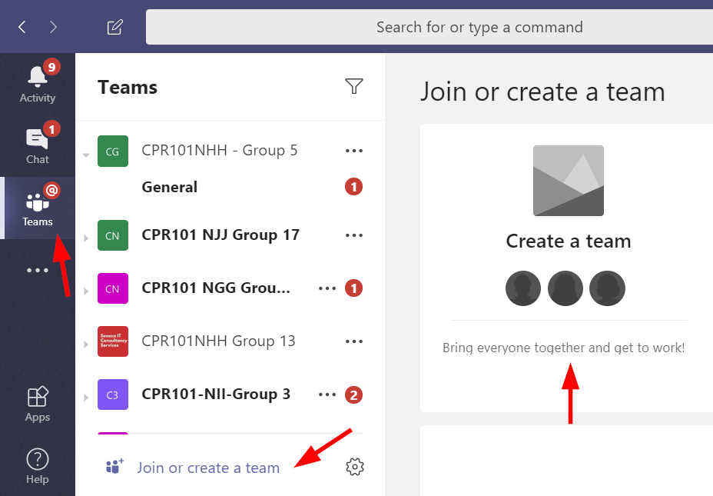
* “Join a team with a code” > enter *code* most recently received from your instructor or as seen in Course Documents > Join a Final Project Group  
  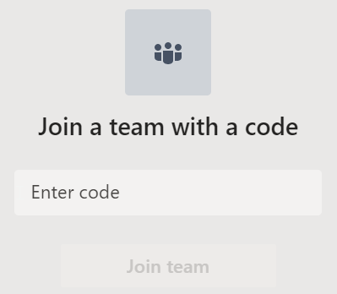

Within that team…

<https://support.microsoft.com/en-us/office/create-and-use-private-channels-16cc2bc9-a468-4469-9d6c-63da5c2a390c>

**Create a private channel**

1. Go to the CP4P team, select **More options** > **Add channel**.  
   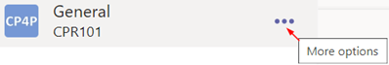  
   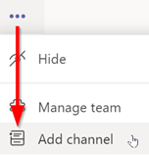
2. Channel set up
   1. **Channel name**:    
      Blackboard full course/class code, your Blackboard group number
   2. Under **Privacy**, change from Standard to **Private - Accessible only to a specific group of people within the team**.
   3. Select **Next**.
3. Type in the name or Seneca user ID of each group member.
   1. People must already be members of the Team. If not, ask them to see Blackboard Announcements for the info to join.
   2. Select **Add**.

People you've added will see it appear in their channel list with a lock next to the name. To see everyone who has been added to the private channel, select the **Open people** pane.

* The Teams environment has two default tabs for…
* Posts: communications and commentary on the project and file contents will be shown in here.
* Files: Use the top level for files that are project artifacts also called deliverables; e.g. Word and Excel files.
  + By always using the same file names, Teams & SharePoint (AKA OneDrive for Business) will take care of version control/history. (No need to create your own versions using file names.)
  + SharePoint maintains files' version history (open in SharePoint and hover pointer over file name, click the three vertical dots to reveal menu).
* Using New, add a Folder called **Development** within Files
* it will contain everything that is not a project artifact, e.g. case study notes. This will keep the deliverables separate from the development process.

|  |  |
| --- | --- |
|  | Please do not use Chat to contact your instructor – use your Private Channel which your instructor is automatically a part of. Feel free to use Chat amongst yourselves. |
|  | Please keep all communications with your instructor in your Private Channel. Use @Instructor_Name to get their attention. |
|  | For communications on a specific artifact, click on the file under Files and Start or continue the conversation. Use @Name to get the attention of your instructor to team member. |

Nomenclature

"Client" is the case study company you are preparing the Proposal, etc for.

**Deliverable #1 – the Assignment Plan – post to the Teams site**

Your group's first task is to create the “Assignment Plan.docx”. It describes the group’s team name (includes your course's section code "abc123***XZZ***" and Bb group number), a link to the Team private channel (under ••• menu), its members, and how the work is shared and assigned to create the artifacts and complete the assignment.

This is the initial plan of who does what based on your best guess of the work to be done to achieve the deliverables. It should be revised and edited as the project progresses. By the time of final submission, it will show details of who did what, both planned and completed, with estimated and actual hours. It is your teams work breakdown structure to accomplish the assignment; the assignment is not just academic, it is very similar to the professional activities and tasks frequently done by IT consultants who routinely respond to RFPs as a way of getting business for their company.

Post a note @your.instructor to review this deliverable.

**Deliverable #2 – draft Proposal, WBS, Budget.  
+ *outline* of one training module**Your group’s Proposal to the case study company (your client) sets expectations for the project. The proposal addresses the client's problems, the business benefits the client is seeking, the work your team will perform for the client that will enable those benefits, the estimated costs, and a demonstration that you understand the details of the work to be done along with the project management skills to do it. **A proposal template document is posted on Bb.**

The Proposal is a summary of the project with your estimate of the work to be done, costs, and phases or sub-projects.

The proposal’s Background section assures the client that you understand their business problem. You do that by reflecting it back to them. It usually opens with relevant business history and a problem statement. What circumstances caused the business to request this proposal from you? 🡺 summarize the client’s problems found in the case study.

The Objectives section lists the client’s anticipated business benefits and project success criteria. 🡺 *After* the Scope of your work is done, what benefits will accrue to the company? What will the client gain by the end of the project? How will their business operations be better?

The Statement of Scope (SoS) is a summary of the products and/or services your team will deliver to satisfy the business objectives. It includes a high-level list of the features and functions the client's business will gain as a result. 🡺 The scope is what you will do: what is included and how your work will be implemented and deployed. The SoS defines and controls what work is *and is not* included in this proposal for the project. Items essential to the success of the project but not within your SoS are stated as necessary conditions.

Avoid TLAs in any communications with the client.

1. Prepare a [Work Breakdown Structure](http://www.brighthubpm.com/templates-forms/2645-what-is-a-work-breakdown-structure/) ([WBS](https://www.teamgantt.com/blog/how-to-estimate-projects-accurately-using-a-work-breakdown-structure)) of the client’s project. Prepare a list or chart showing the project's detailed tasks in sequence, the estimated hours to complete, if the task is dependent upon another task being finished before this task can be started, and the skill level needed to complete each task.   
     
   The WBS is a centrally important artifact. It supports the contents of Proposal and the Budget. The WBS provides:  
   * the detail to support the Statement of Scope in the Proposal.   
   * the critical path to calculate calendar start/end dates of the Proposal's Project Stages and Milestones.   
   * hours and skill levels used by the Budget to calculate Services costs.  
     
   The WBS = tasks and sub-tasks to do in sufficient detail that an estimate of time and effort to accomplish them can be made. E.g. "Install server" can be a little or big task depending on the task’s scope which can range from ‘plug it in and turn it on’ to complex configuration. The WBS 'breaks down' the big chunks of work into small packages of work which can be assigned to a person and be accomplished in a time span of hours to days but not weeks or months. For all the work steps -- describe **what** needs to be done in enough detail for an experienced person who has the skill to do it. Then, estimate the hours needed for each **what**. It is an *estimate*, not a prix fixe quote. Determine the sequence needed, decide which tasks are independent and can be done in parallel, which tasks must be done serially (dependent on the completion of other tasks); finally, which tasks are repeated. (Like programming, there are three kinds of logic: sequential, decision/conditional, iterative/looping.) The longest series of serial tasks is your critical path which determines start and end dates of each phase or stage of the project (assume an 8 hour work day).  
     
   Although you may have to hire people to complete the project, that hiring process is NOT part of the client's project. It is part of your consultancy's operations overhead. You can charge related project management hours to the client's Services budget.
2. Prepare a detailed cost estimate of the project to support the Project Proposal’s summary of costs and budgets.   
   Use the WBS hours and skill levels to support the labour and services costs shown in the budget.  
   **N.B.** Business proposals & budgets almost always omit / ignore sales taxes. Value added taxes like GST/HST make sales taxes paid on purchases an input tax credit to GST/HST collected on sales. Thus, it becomes an accounting exercise affecting only cash flow (not your problem).

Send a Team note @*your.instructor* to review this deliverable.

**Deliverable #3 –** **client's end user Training Module**

**Create a two-minute Training Module (instructional video or narrated PowerPoint / Sway or Adobe Spark presentation) on any course topic about cloud computing you feel would benefit your client’s management (to fully appreciate your proposal) or employees (when they use cloud services).**

If a videois used,it must be in H.264 MPEG-4 .MP4 file format which can be streamed and rendered by all browsers. Users do not care if it plays on your system, they care only if it plays on their system. Other formats may require software installation – a non-starter – or a trip to planet Apple.

The IT industry regularly uses this type of just-in-time user education resource. The audience is usually end users (company employees). Consider why users would invest their time to watch it. To make their lives easier and better is why.

The presentation must be an original work (you cannot use existing YouTube or other resources as part of your presentation). A PowerPoint requires voice over by one or more group members. Do **not** use music; in this type of presentation, music is almost always a distraction from the voice-over (no need for a soundtrack to cue emotion) and/or an annoyance (not everyone likes the music you like). The presentation can use slides, [animation](https://www.google.ca/search?q=video+animation+maker), [screen](https://www.google.ca/search?q=screen+capture) [shots](https://www.take-a-screenshot.org/), [screen recording](https://www.google.ca/search?q=screen+recording), and/or live action. Avoid displaying a screen with large amounts of text — a text crawl is allowed only when starting a Star Wars movie. Summary bullet points and/or images are fine to support voice over. A video of a talking head reading a script is a form of torture which will torpedo your chance of success.

Sources must be cited and referenced for any concepts, text, or images used in the project. Do that at the end of your presentation.